**CA298 Report – Full Stack Development**

**PLAGIARISM STATEMENT**

I certify that this assignment/report is our own work, based on our personal study and/or research and that we have acknowledged all material and sources used in its preparation, whether they be books, articles, reports, lecture notes, and any other kind of document, electronic or personal communication. We also certify that this assignment/report has not previously been submitted for assessment in any other unit, except where specific permission has been granted from all unit coordinators involved, or at any other time in this unit, and that We have not copied in part or whole or otherwise plagiarised the work of other students and/or persons.

**Signature:** Alif Hossain

Jamie Clarke

**Student Numbers:**

Jamie Clarke – 18398783

Alif Hossain – 17314941

**Website Name: NBA Store**

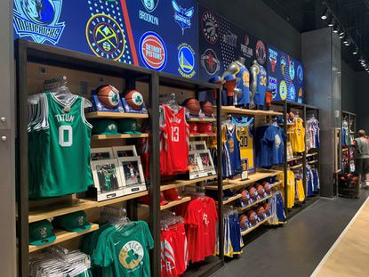

**NBA Store**

**Official NBA Merchandise**

**Introduction**

Our website is our own version of an NBA store selling mainly jerseys as well as a few accessories e.g basketballs and arm sleeves. This website is mainly targeted towards people our age and older looking for authentic NBA jerseys in Ireland as we both know personally how difficult it is to get them here. Choose from a wide selection of NBA goods at the NBA Store to complete your collection. Aside from NBA jerseys, t-shirts, and sweatshirts, our store has a large selection of fully licensed NBA souvenirs to display in your home or workplace. Find the most up-to-date player gear in a variety of sizes so you and your fellow fans can promote your favorite NBA club in true NBA flair. The NBA Store has the largest online selection of basketball jerseys and apparel.

**Website Design**

Sitemap

When you first visit the NBA shop website, you'll be sent to the home page, where you'll find a variety of ways to learn more about the firm and the individuals behind the initiative. Otherwise, you may create an account and visit our online store, where you may browse our items and add them to your cart. After that, you may either return to our homepage and continue exploring, or you may finalize your purchasing at the checkout and then continue exploring on our website.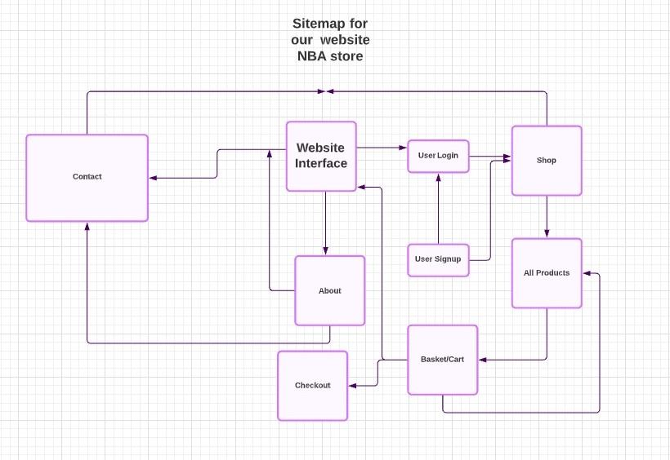

**A list of your URLS**

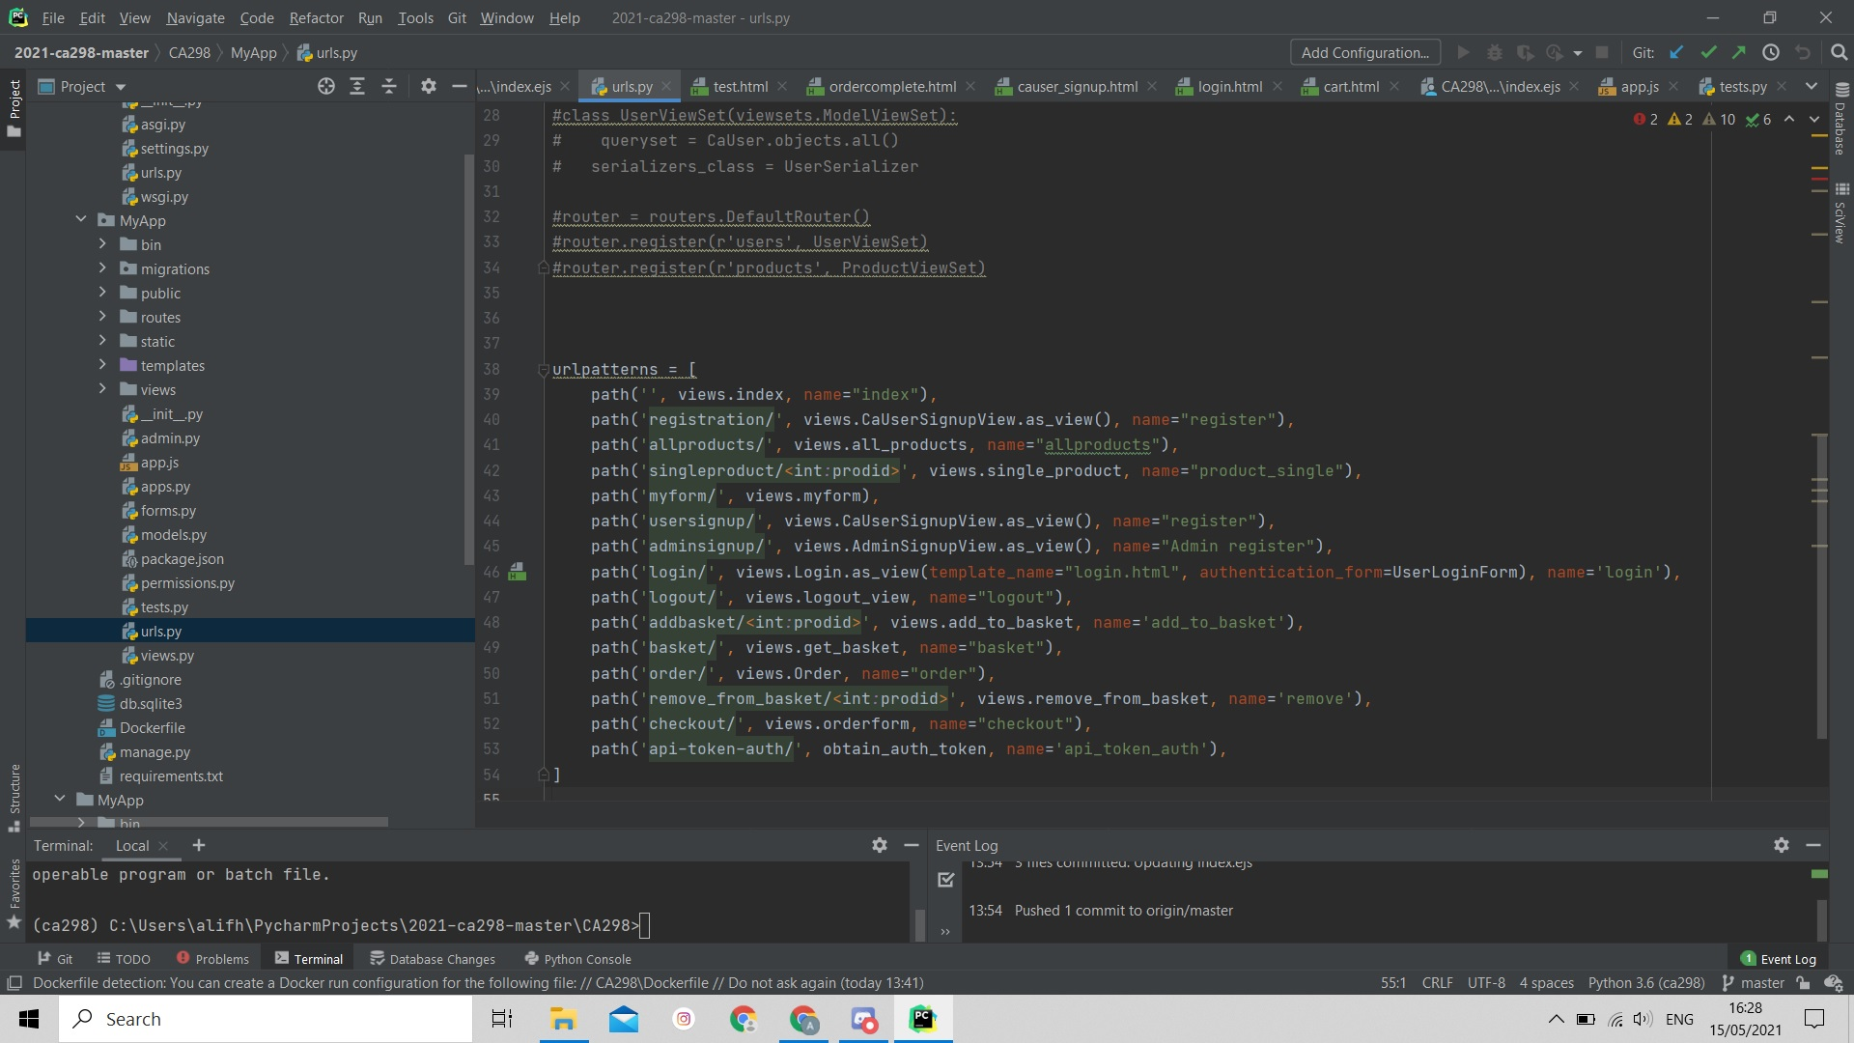

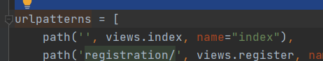

This url links us to the homepage of the website. It contains the html and css code for our homepage that's saved in index.html.



This url link allows the user to make an account and register as a member of the website. This will take you to the registration page where you will be asked to fill out some details in order to make an account on our website.



This url links us to the products that are in the shop’s page. We used the template all_products.html to list out all the products and their details. This page requires the user to login before accessing it, once done this will take you to a virtual shop where you can browse our range of products.



MyForm/ - This page requires the user to be logged in, once they’ve done so this will bring them to a page with their details.



UserSignup/ - This is the same as the registration page.



AdminSignup/ - This is a sign up page for only admins and cannot be accessed by anyone. Once signed up the admin can add and delete items from the shop.



Login/ - This will bring you to the login page where you will be asked to enter your details.



Logout/ - this will automatically log you out, and return you to the home page.

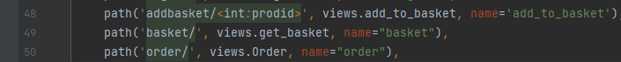

Addbasket/<int:prodid - this added a single item to your basket. int:prodid was the individual number given to all products.



basket/ - brought you straight to your basket and gave you the offer of completing the order

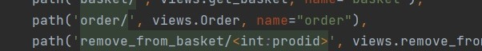

order/ - gives you a view of your order.

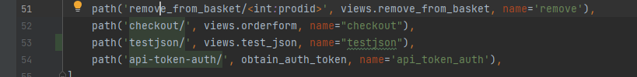

remove_from_basket/<int:prodid> - this removes your items from the basket



checkout/ - This brings your straight to the checkout



api-token-auth/- This gives users the ability to access multiple software.

**UML Sequence Diagrams**

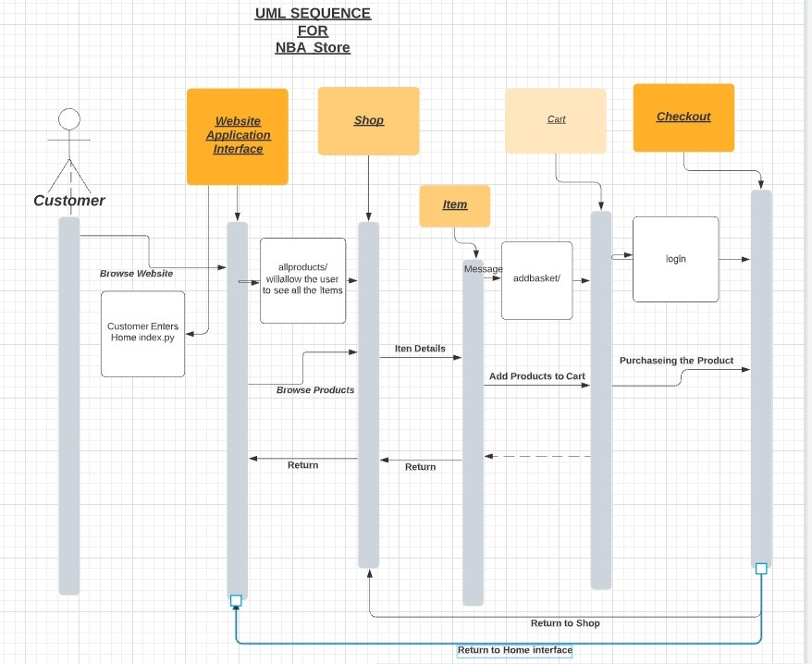

* The uml sequence model showing the groups of objects collaborating.
* The diagram captures the behavior of a single use case. 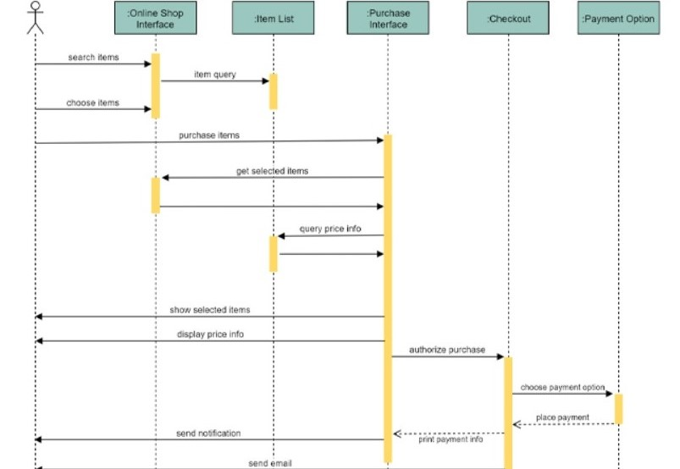
* It shows objects and the messages that are passed between these objects for the particular use case.
* A good UML sequence design can have lots of small methods in different classes. Because it is difficult to figure out the overall behavior of the design we draw a sequence diagram to verify the behavior.

**Links & Extras**

**Gitlab Repo:** [**https://gitlab.computing.dcu.ie/hossaia5/2021-ca298-master**](https://gitlab.computing.dcu.ie/hossaia5/2021-ca298-master)

**Youtube Video Show-casing our website:**

**https://youtu.be/08oxRp9Noro**

**References**

* **LucidChart:** [**https://lucid.app/documents#/dashboard**](https://lucid.app/documents#/dashboard)
* W3 schools
* CA298 Full Stack notes, lectures and labs helped us get a better understanding of how to go about operating back-end code and laying out our website.